**Project Design Phase-I**

**Solution Architecture**

|  |  |
| --- | --- |
| Date | 5 NOVEMBER 2022 |
| Team ID | PNT2022TMID13490 |
| Project Name | Gas Leakage monitoring & Alerting system |
| Maximum Marks | 4 Marks |

**Solution Architecture:**

* This project helps the industries in monitoring the emission of harmful gases
* In several areas, the gas sensors will be integrated to monitor the gas leakage
* If in any area gas leakage is detected the admins will be notified along with the location
* In the web application, admins can view the sensor parameters.
* The traditional Gas Leakage Detector Systems though have great precision, fail toacknowledge a few factors in the field of alerting the people about the leakage.
* Therefore we have used the IoT technology to make a Gas Leakage Detector having Smart Alerting techniques involving calling, sending text message and an e-mail to the concerned authority and an ability to predict hazardous situation so that people could be made aware in advance by performing data analytics on sensor readings.
* IoT technology to make a Gas Leakage Detector having Smart Alerting techniques involving calling, sending text message and an email to the concerned authority and an ability to predict hazardous situation so that people could be made aware in advance by performing data analytics on sensor readings.

**Solution Architecture Diagram:**

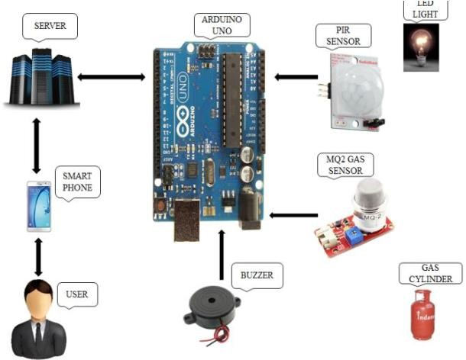

*Figure 1: System Architecture*

*Technical Architecture:*

